**2.2 Interactive Graphics**

This is the type of computer graphics in which the user can control the pictures produced. It involves two-way communication between user and computer. The computer upon receiving signal from the input device can modify the displayed picture appropriately. To the user it appears that the picture changes instantaneously in response to his commands. The following fig. shows the basic graphics system:

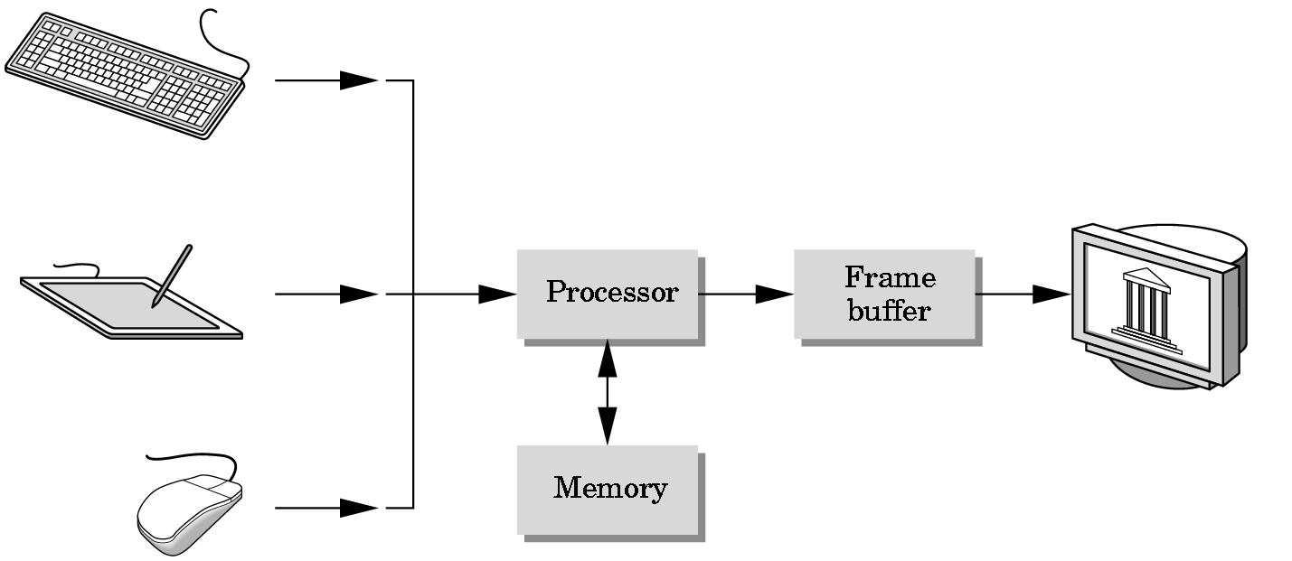

Input devices Image in FB output devices

Fig 2.1 Basic Graphics System

**2.3 About OpenGL**

OpenGL is an open specification for an applications program interface for defining 2D and 3D objects. The specification is cross-language, cross-platform API for writing applications that produce 2D and 3D computer graphics. It renders 3D objects to the screen, providing the same set of instructions on different computers and graphics adapters. Thus it allows us to write an application that can create the same effects in any operating system using any OpenGL-adhering graphics adapter.

In Computer graphics, a 3-dimensional primitive can be anything from a single point to an ‘n’ sided polygon. From the software standpoint, primitives utilize the basic 3-dimensional rasterization algorithms such as Bresenham's line drawing algorithm, polygon scan line fill, texture mapping and so forth.